TASK 1

Создание первого приложения

from fastapi import FastAPI  
from fastapi.responses import HTMLResponse  
app = FastAPI()  
@app.get("/")  
def read_root():  
 html_content = "<h2> Hello, my name is Artur!</h2>"  
 return HTMLResponse(content=html_content)  
app = FastAPI()  
@app.get("/")  
def read_root():  
 html_content = "<h2>Hello, my name is Artur!</h2>"  
 return HTMLResponse(content=html_content)

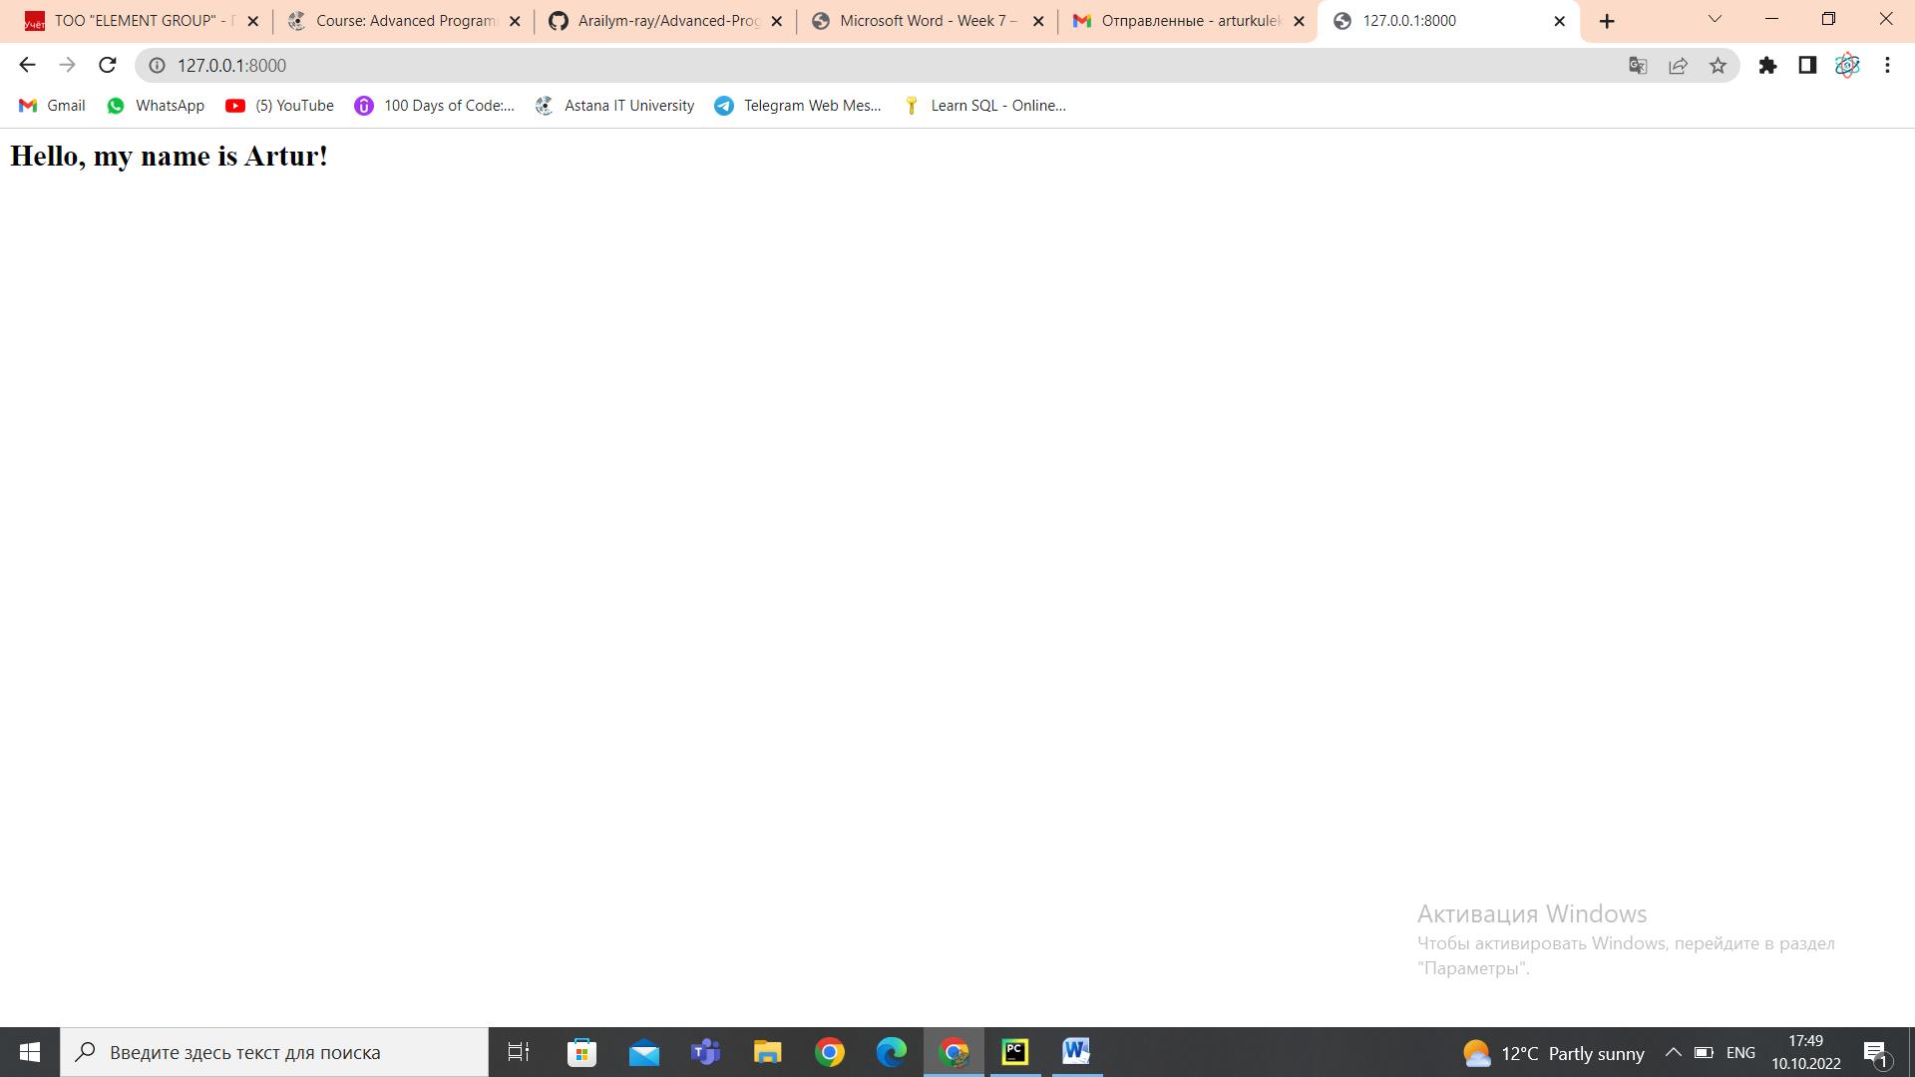

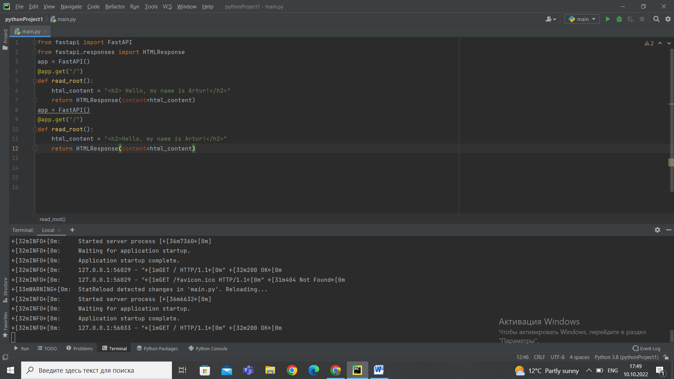

TASK 2

Класс FastAPI и обработка запроса

from fastapi import FastAPI  
app = FastAPI()  
from fastapi import FastAPI  
app = FastAPI()  
@app.get("/")  
def root():  
 return {"message": "Hello my name is Artur"}

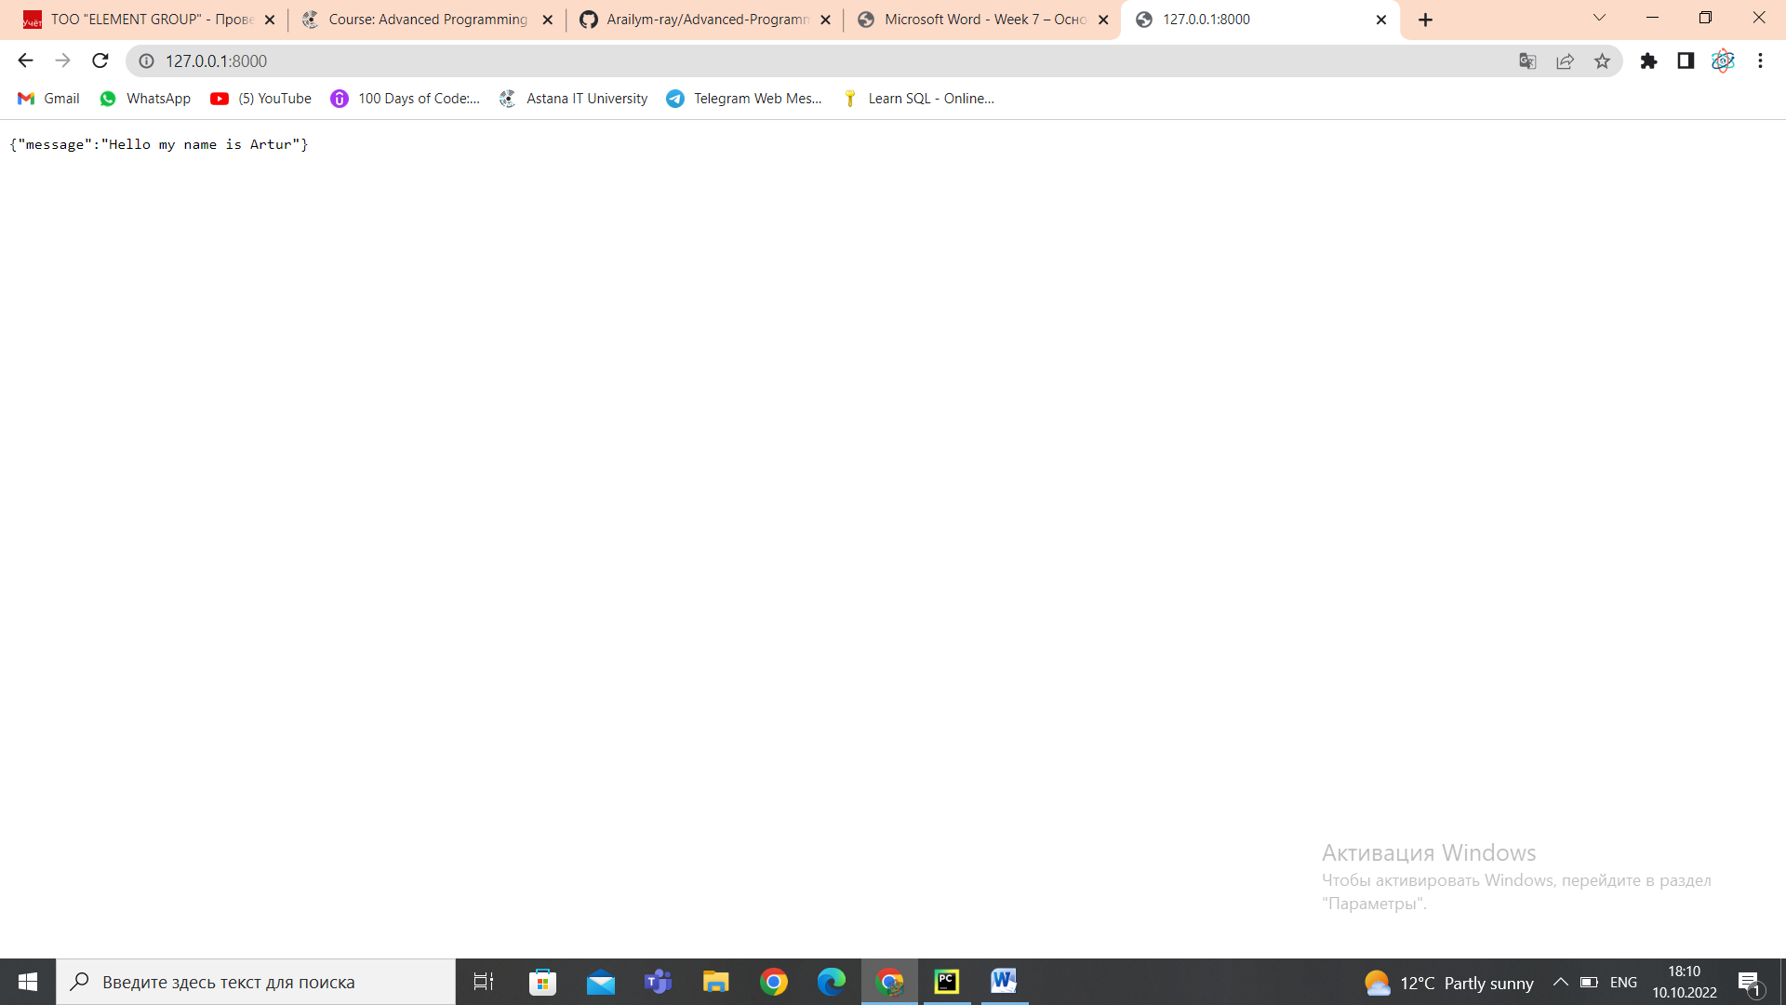

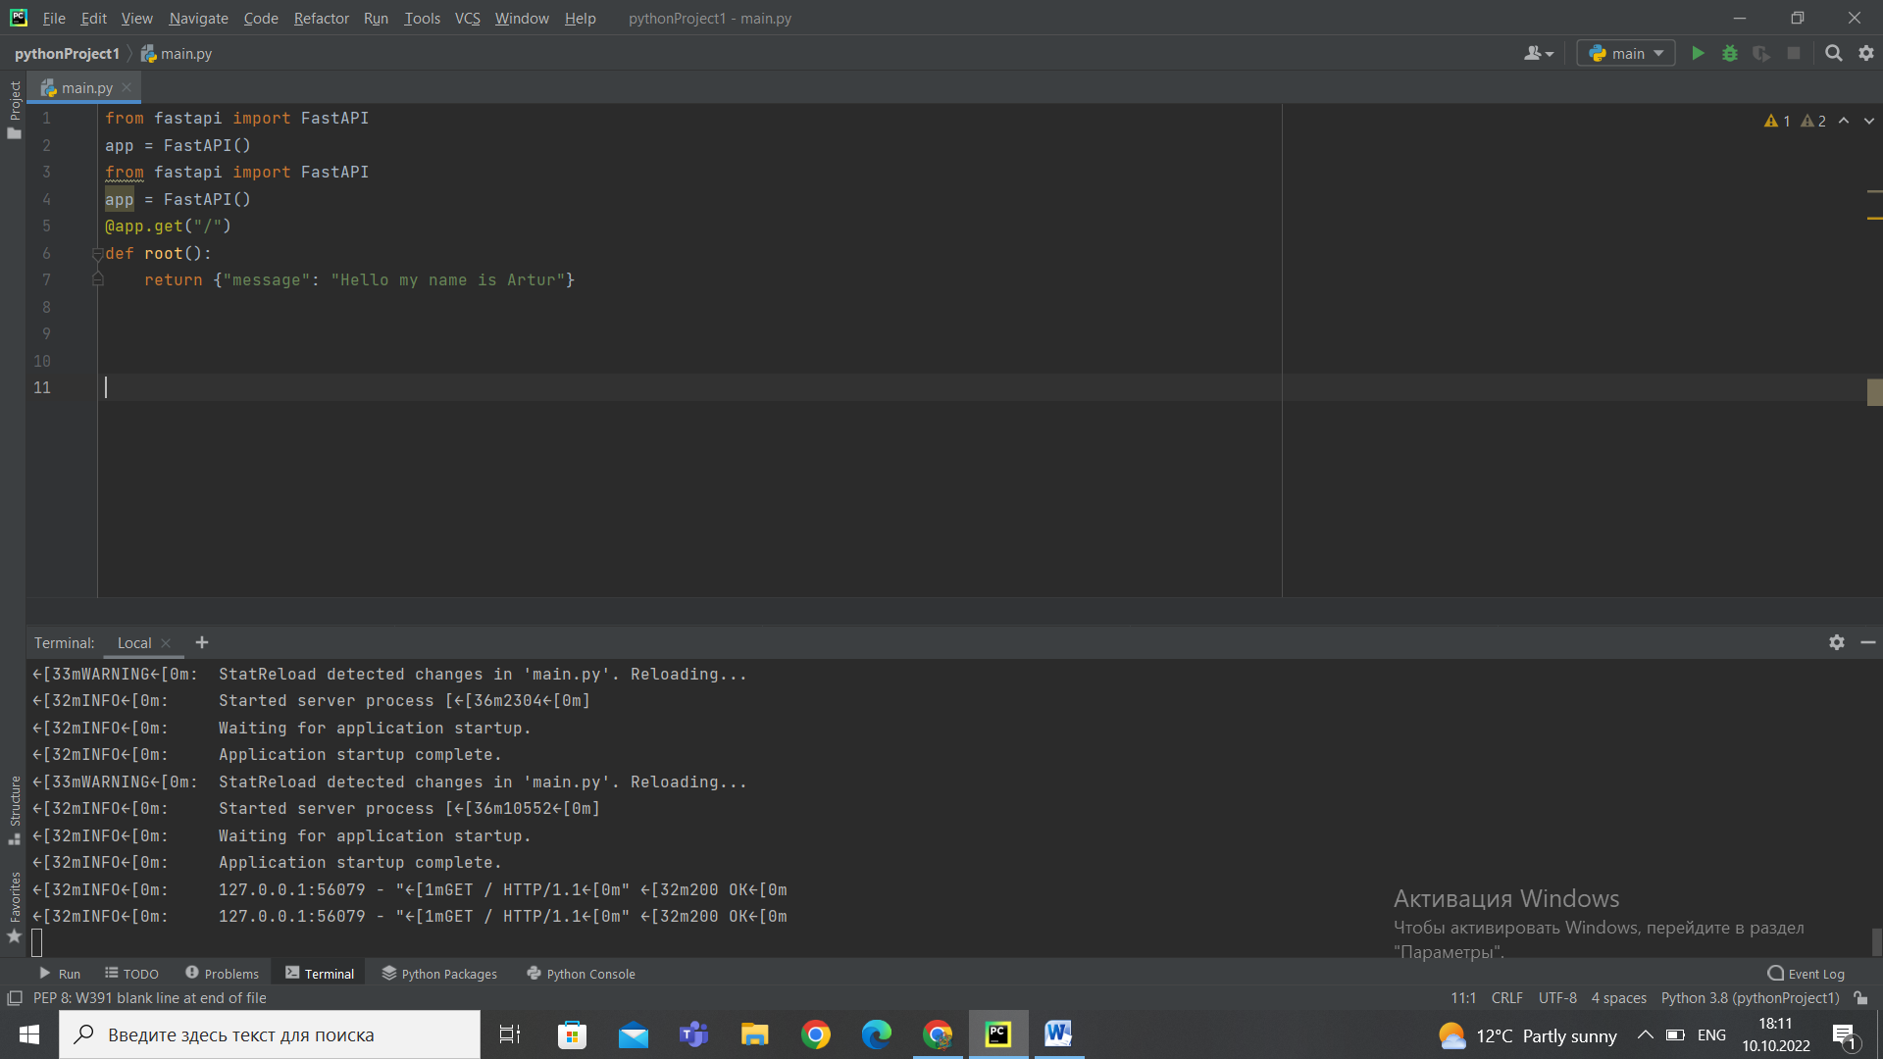

from fastapi import FastAPI  
app = FastAPI()  
@app.get("/")  
def root():  
 return {"message": "Hello Artur!"}  
@app.get("/about")  
def about():  
 return {"message": "О сайте"}

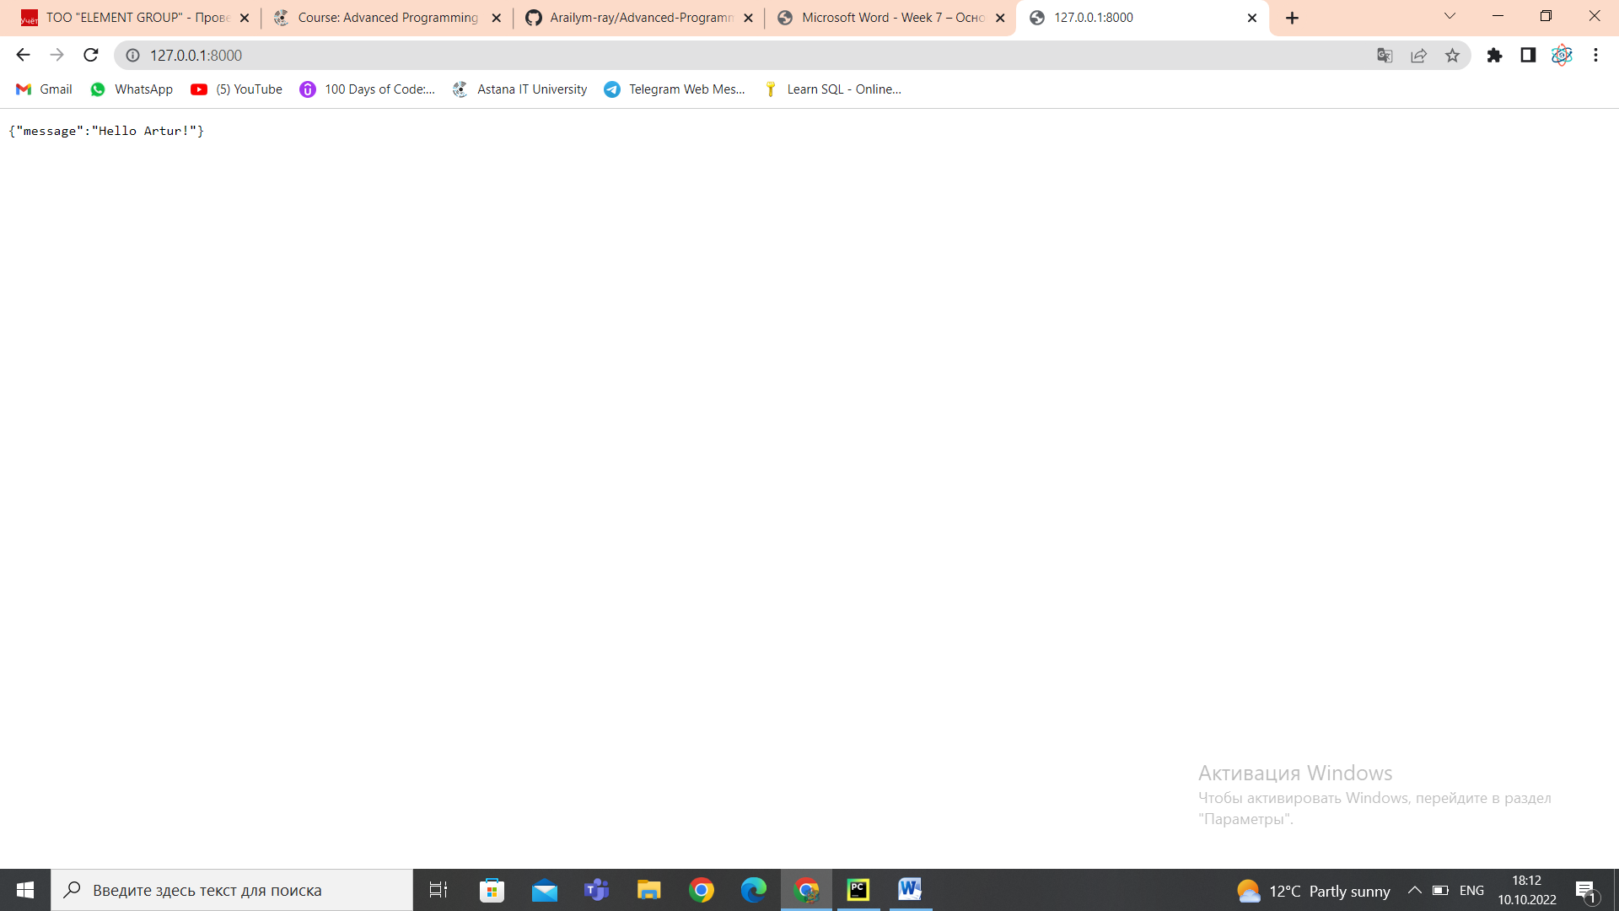

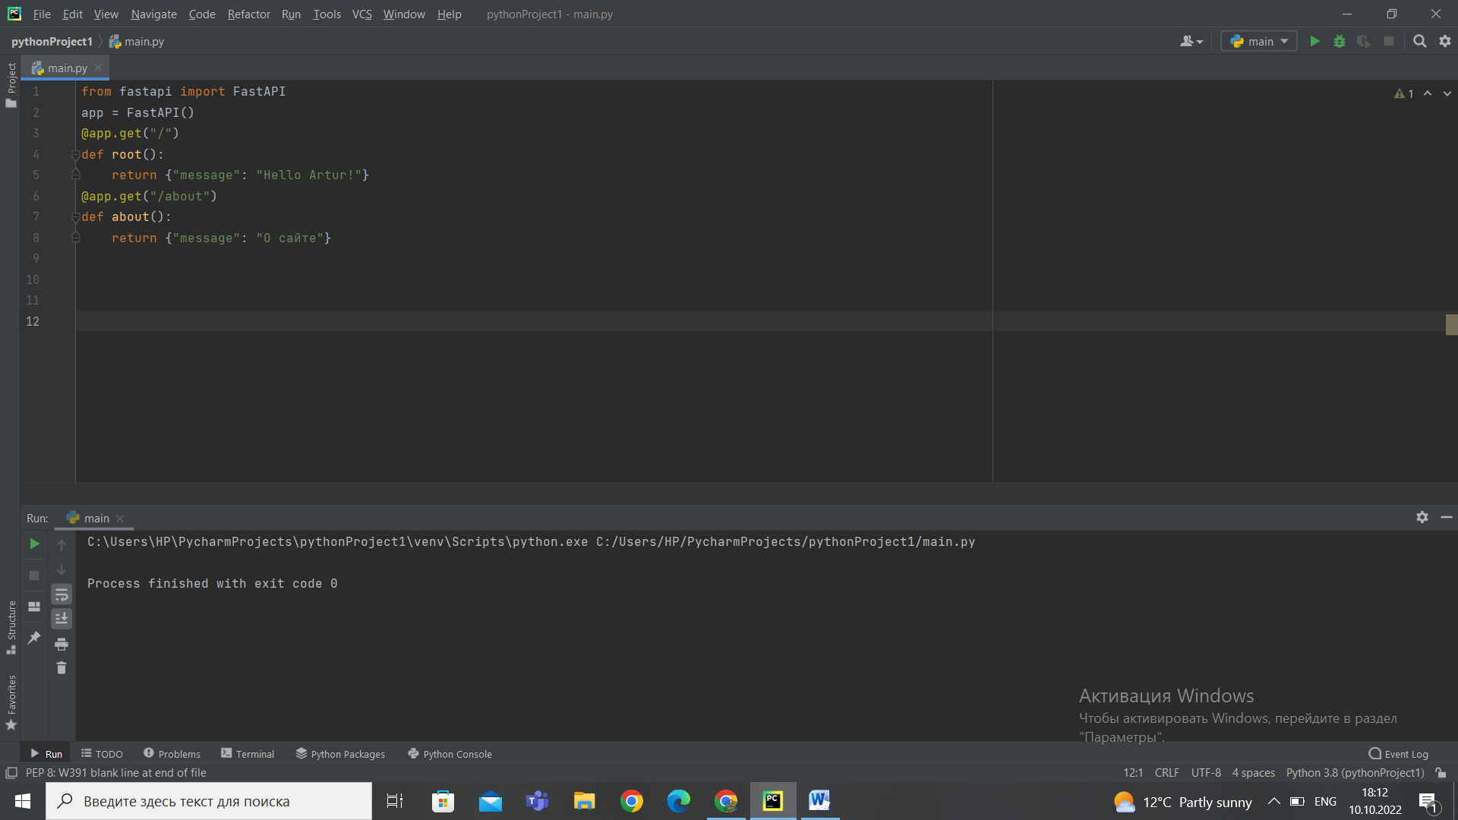

TASK 3

Отправка ответа

from fastapi import FastAPI  
from fastapi.responses import HTMLResponse  
app = FastAPI()  
@app.get("/")  
def root():  
 data="<h2>Hello Aktobe</h2>"  
 return HTMLResponse(content=data)

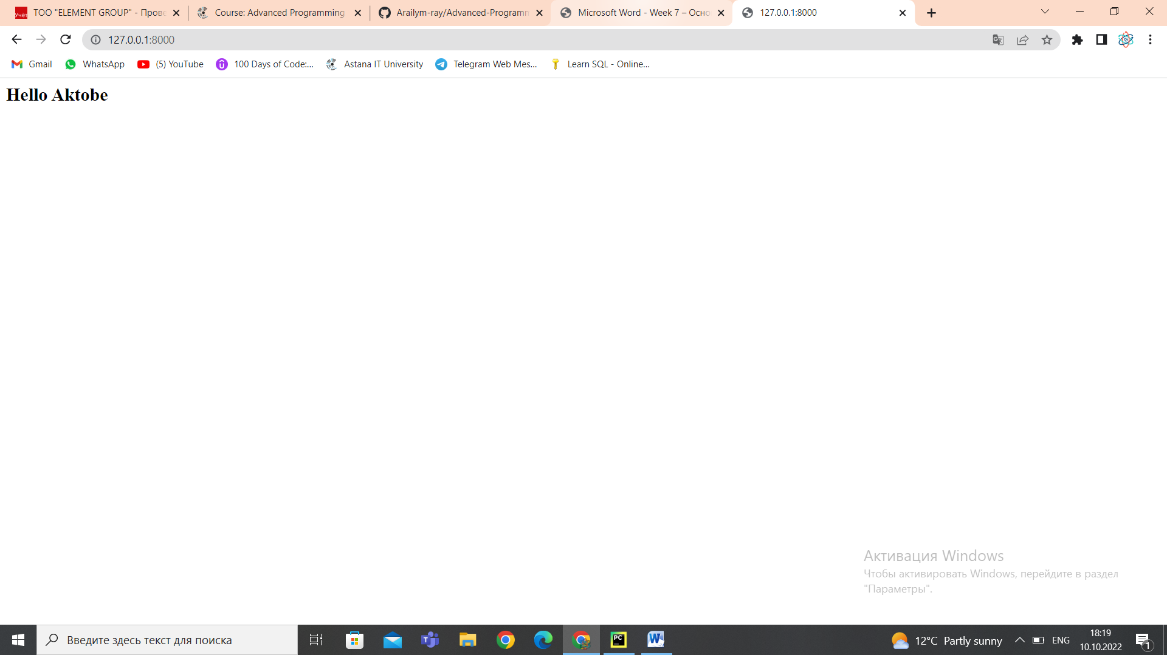

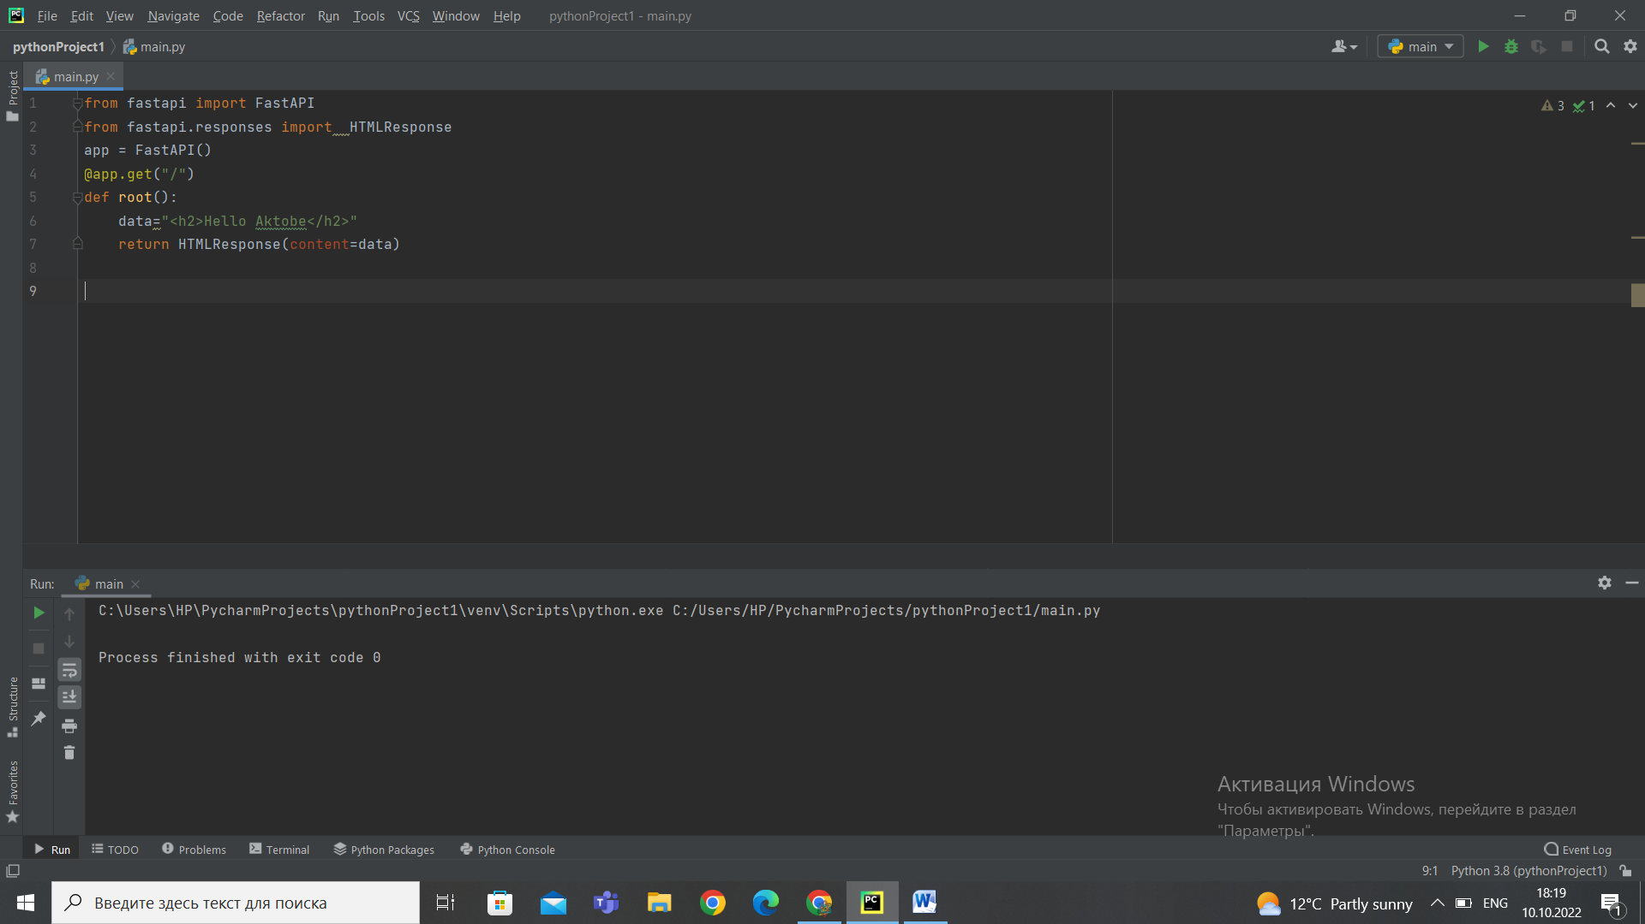

TASK 4

Отправка файлов с сервера

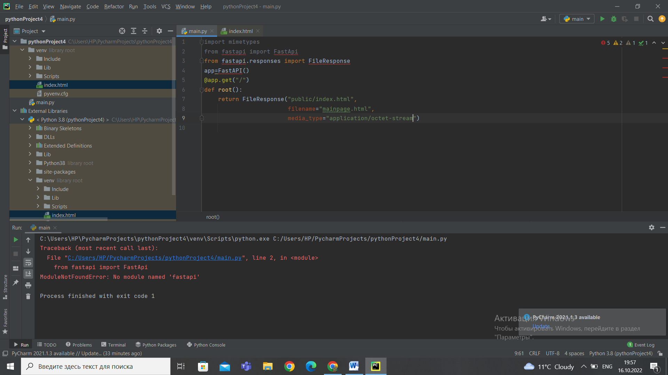

TASK 5